# PYTHON PROGRAMMINg LAB

**Project Report**

# 

# Hangman Project

# using Tkinter in python

Project by

Saket Patil 219311231

Ayush Mishra 219309111

**Hangman Game**

Hangman is a guessing game for two or more players. One Player thinks of a word, phrase or sentence and other(s) tries to guess it by suggesting letters within a certain number of guesses. Originally a Paper-and-Pencil game, there are now electronic version.

The following project was created using python’s Tkinter library.

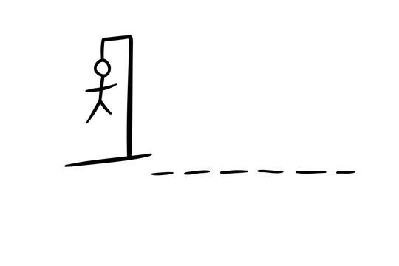

**What is Tkinter and why do we use it?**

Python has a lot of GUI frameworks, but Tkinter is the only framework that’s built into the Python standard library. Tkinter has several strengths. It’s **cross-platform**, so the same code works on Windows, macOS, and Linux. Visual elements are rendered using native operating system elements, so applications built with Tkinter look like they belong on the platform where they’re run.

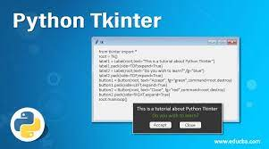

Although Tkinter is considered the de facto Python GUI framework, it’s not without criticism. One notable criticism is that GUIs built with Tkinter look outdated. If you want a shiny, modern interface, then Tkinter may not be what you’re looking for.

Example of calculator giver below:

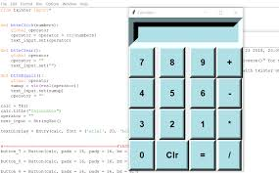

However, Tkinter is lightweight and relatively painless to use compared to other frameworks.

This makes it a compelling choice for building GUI applications in Python, especially for applications where a modern sheen is unnecessary, and the top priority is to quickly build something that’s functional and cross-platform.

**Code**

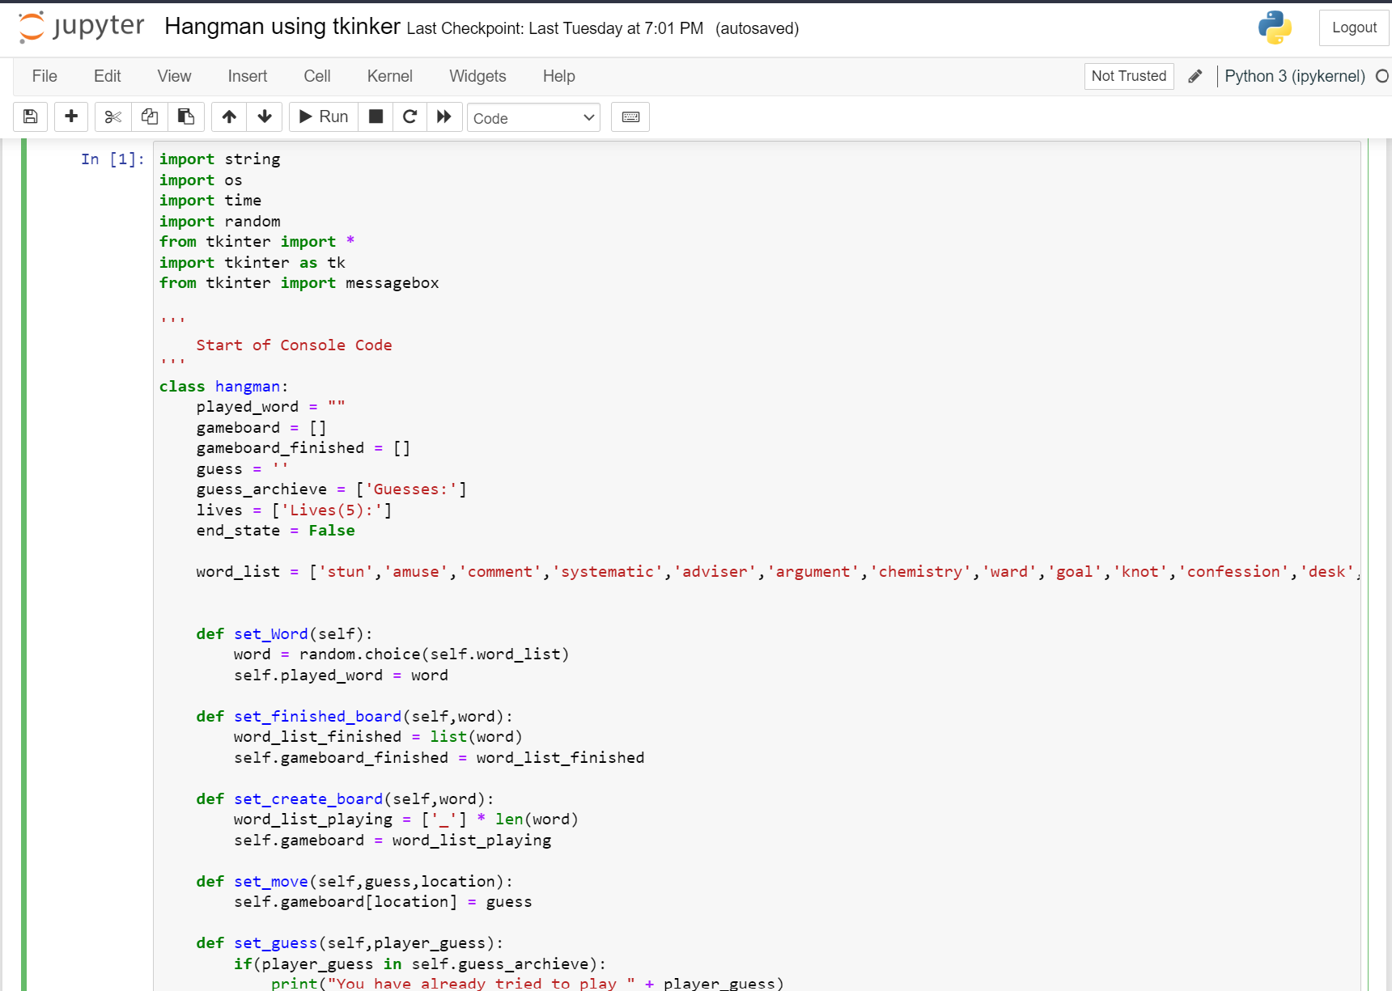

**Execution**

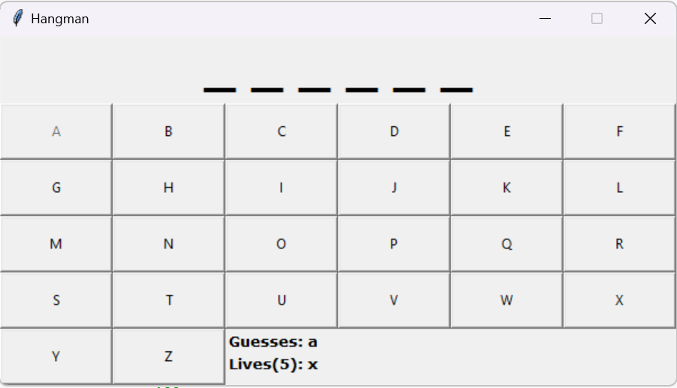

**Result**

The code runs pretty flawlessly every single time. In conclusion, we got to learn a lot about tkinter and its usefulness. Tkinter thus can be used in various other placers with very creative applications.

**Thank You!**